University of Pittsburgh: iLab Institution Manual

Contents

Overview 2

Logging into iLab: 2

Switch to New Design: 4

Navigating iLab: 4

View Requests: 5

Institution Dashboard: Pitt 6

Summary of Cores 6

User Management 6

Pending Lab Access Request 6

Research Groups 7

Account Numbers 9

Manage Research Groups (Labs) & Account Numbers 9

Accessing your Lab 10

Managing Members and Account Numbers in a Lab 10

Managing Members of your Group 10

Accepting a member into your lab 11

Assigning Account Numbers to Members of a Lab 11

Requesting Access to Non-sponsored Account Numbers 12

Custom Billing Fields 14

Navigating to Core Default Custom Billing Fields: 14

Navigating to Service Level Custom Billing Fields 14

Navigating to Equipment/Calendar Level Custom Billing Fields 15

Filling out Custom Billing Fields: 16

Billing Process 18

Invoices: 18

iLab Help Site 19

# Overview

The iLab/Pitt Financial Integration allows PIs, Financial Managers, Researchers and Core Managers to use valid payment information (Account Numbers) at each step of the request and billing process for core facilities. PI’s and/or lab managers assign Account Numbers to individuals who will utilize Pitt cores. Researchers can order services using Account Numbers and core managers can bill for these services knowing that they are using valid Account Numbers. This document can be used by institution admins, PI’s, lab managers, and core staff as a guide for using iLab. This document will review logging into and navigating iLab, assigning Account Numbers and making any appropriate changes to labs. For an overview of iLab terms, [click here](https://help.ilab.agilent.com/35322-getting-started/261285-key-ilab-terms).

# Logging into iLab:

The iLab/Pitt ID SSO integration allows for internal users to seamlessly register and login to iLab using their Pitt credentials. For external registration instructions, [click here](https://help.ilab.agilent.com/99540-getting-started-with-ilab/325013-registering-with-ilab).

**Registration Process for Internal Users**

1. Navigate to the following URL: <https://pitt.ilab.agilent.com/account/login>
2. Bookmark this URL for future use.
3. Once on the iLab login page, select ‘Sign in using PITT credentials.’
4. At this point you will be prompted to provide your username and password.

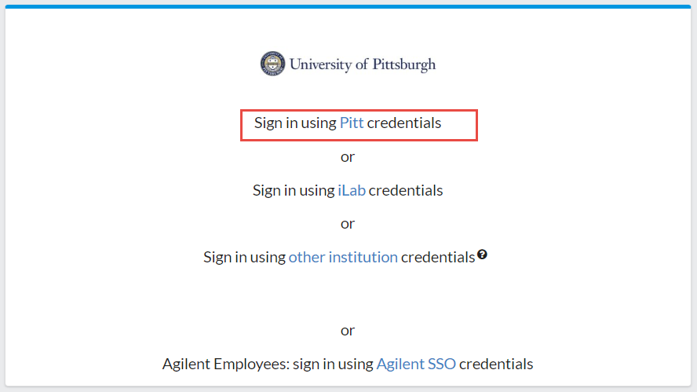

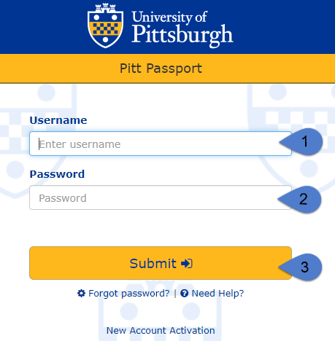

1. If this is your first time logging in, once you authenticate you will be directed to a registration page.

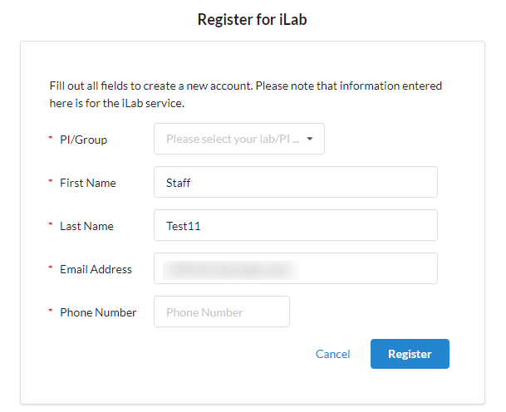

* 1. First select the appropriate PI/Group from the first drop down.
  2. Your first name, last name, and email address will be pre-filled. Complete any remaining required fields.
  3. Click ‘Register.’ The next page you see will be the ‘Greeting Page.’
  4. The PI you selected has been sent an email informing them that they need to approve your account.
  5. The PI is reminded each business day, but you have the opportunity to send an additional reminder.
  6. You will also receive a Welcome email with brief getting started instructions.
  7. Once your account has been approved you will receive an email notifying you.

1. Now you can login following steps 1-4 to utilize the core facilities within iLab.
2. Once logged in you will be on the iLab homepage dashboard. Make sure to set your time zone!

# Switch to New Design:

Your account may be in the old design, the first step is switching to the new design!

1. Click the ‘Try new design!’ link at the bottom of your screen near the iLab Agilent trademark.
2. Your page will refresh automatically and when you navigate to your institution dashboard it will be in the new design.

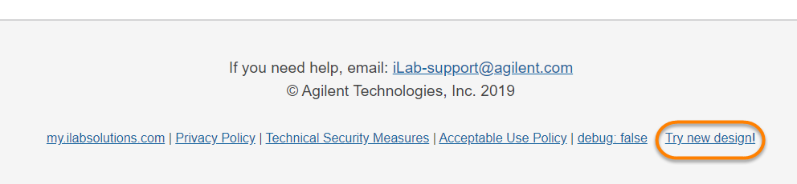

# Navigating iLab:

The left-hand navigation panel will be used to navigate through iLab functionality. To view additional information about overall iLab navigation, [click here](https://help.ilab.agilent.com/35322-getting-started/263626-overall-navigation).

*Image 1.1*: **Core Facilities:**

* Click *‘Core Facilities’* to see any live Pitt cores.
* You can also search for core facilities outside of Pitt.

*Image 1.2:* **View Requests:**

* Click *‘View Requests’* to see a list of requests per core. This area is where a PI/Lab Manager can approve/deny requests or provide a Account Numbers(s).
* Only available for Institution admins, PIs, and lab managers.

*Image 1.3:* **My Groups**

* Click *‘My Groups’* to see a list of the labs in which you manage.

*Image 1.4:* [University of Pittsburgh]:

* This link is **ONLY** available to those with an Institution Admin/Financial Admin membership.
* Click this link to access the Institutional Dashboard which includes a full list of cores (live and in development), Institution memberships, full list of internal labs, and a full list of Account Numbers.

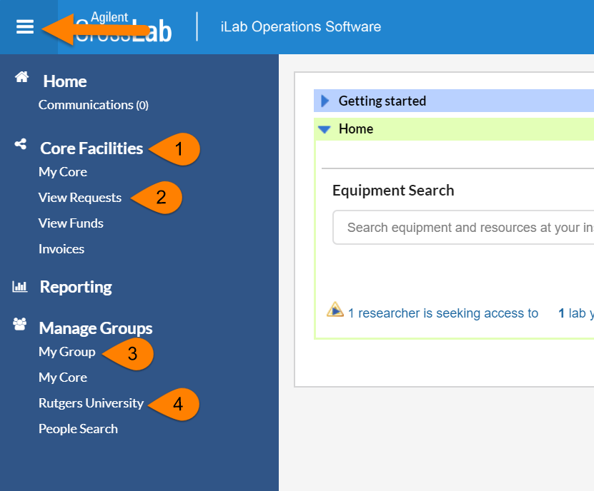

# View Requests:

*‘View Requests’* allows you to see a list of requests per core. This area is where a PI/Lab Manager can approve/deny requests or provide a Account Numbers(s). This section is only available to Institution Admins, PIs, and Lab Managers. For additional information on the ‘View Requests’ page, [click here](https://help.ilab.agilent.com/36900-managing-your-group/300355-view-requests).

1. Click ‘View Requests’ to see all requests.
2. Use the tabs along the top to navigate between requests.
   1. **Awaiting Approval**: Displays any request made by a researcher from your lab to a core that has exceeded the pre-approved cost that the lab has set. This request now requires approval from a financial manager to proceed with the service request. Simply click ‘Agree’ or ‘Disagree’.
   2. **Require Payment Info**: Displays any request made by a researcher that does not have a Account Numbers selected to charge.
      1. To update, simply click the $ icon and select a Account Numbers. Click save.

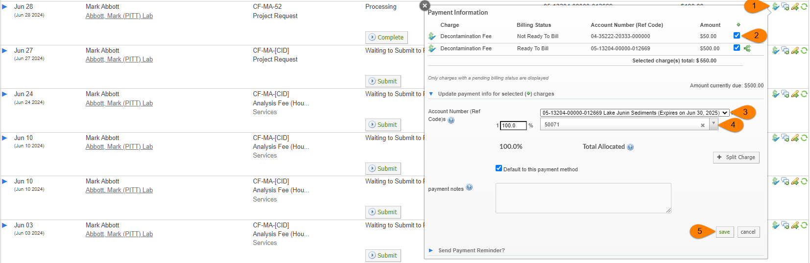

* 1. **Processing and Recently Completed:** Displays all current or recently finished request from any researcher within your lab(s) that does not require actions.
  2. **All Requests:** Display all requests from anyone within your lab.

# Institution Dashboard: University of Pittsburgh

The institution dashboard is accessible by institution admins, institution financial managers, and institution managers. You can navigate to your institution dashboard by clicking the ‘Pitt’ link in the left-hand menu. On your dashboard you can view a summary of cores, manage users and Account Numbers, view billing events across all cores, run reports at the institution level, and adjust settings. For additional information on the institution dashboard, [click here](https://help.ilab.agilent.com/37595-institution-dashboard/266672-overview).

## Summary of Cores

On the ‘Summary of Cores’ tab you can view all cores at Pitt that are live, in development, and details about the core. Each core name is a hyperlink which will take you to the core. There is also a link icon to the left of the core’s name which will provide you with the custom URL for that core. For additional information about the ‘Summary of Cores’ tab, [click here](https://help.ilab.agilent.com/37595-institution-dashboard/266673-summary-of-cores).

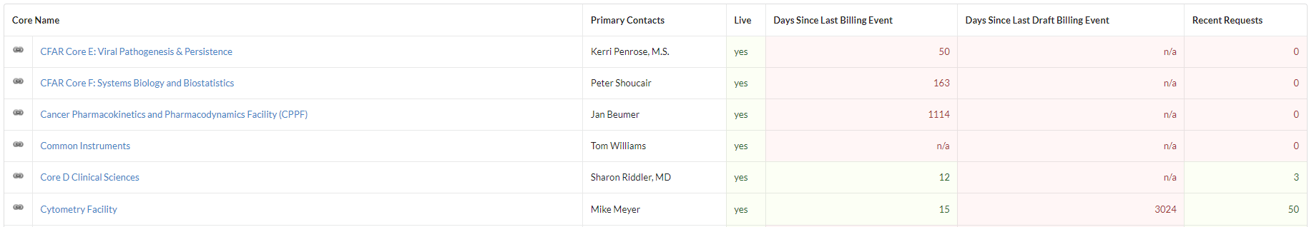

## User Management

On the ‘User Management’ tab you can view and manage pending lab access requests, research groups (labs), memberships to Pitt, and Account Numbers. For additional information about the ‘User Management’ tab, [click here](https://help.ilab.agilent.com/37595-institution-dashboard/299269-user-management).

### Pending Lab Access Request

The ‘Pending Lab Access Request’ will appear only when a new internal user registers for an iLab account or is requesting access to a new/additional lab. The grey number on the ‘User Management’ tab indicates the number of outstanding requests. PIs and/or Lab Managers will act on these requests within their lab. An institution admin can act on these requests on this dashboard.

1. The black bolded name is the lab the user is requesting access to, typically the PI’s name.
2. Below the lab name is the name of the user requesting access.
3. Hover over the user’s name to display action buttons.
   1. **Accept:** If the user is part of the lab selected, click ‘Accept’ to add them into the lab.
   2. **Change Lab:** If the user is not part of the lab selected but their correct lab is in iLab, select ‘Change lab.’
   3. **Reject:** If the user is not part of any lab within iLab.

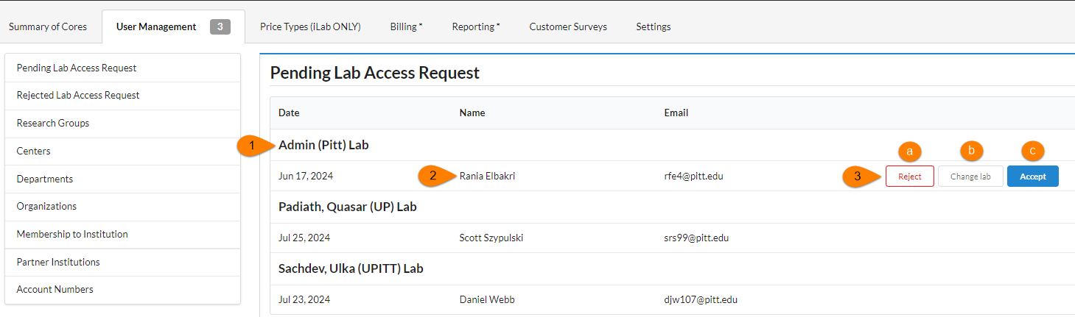

### Research Groups

Research Group, also known as labs, is a central location for a PI, their researchers, and Account Numbers. The PI and lab manager can manage the researchers and assign Account Numbers within the lab. The labs in this section are created through the fund file that Pitt sends iLab nightly. The name of the lab is a hyperlink to the lab. For additional information on managing a Research Group navigate to the Manage Research Groups (Labs) & Projects section of this document.

#### Manually Creating a Lab:

There may be scenarios where a PI does not come through in the nightly fund file but they need an account and lab within iLab. The PI will need to register in iLab **first** and their lab will need to be manually created by an **Institution Administrator.**

1. It is important to first confirm that the PI does not have a lab in iLab because you do not want to create a duplicate lab.
   1. On the ‘User Management’ tab within the ‘Research Group’ section search for the PI.
   2. If the PI’s lab exists, do not proceed with creating a lab.
   3. If the PI’s lab does not exist, you can proceed.
2. The PI must register **before** you can create the lab.
   1. When the PI is registering, they will select to be in the ***Admin (Pitt) Lab***
3. Click ‘University of Pittsburgh’in the left-hand panel.
4. Navigate to the ‘User Management’ tab.
5. Accept the PI into the Admin (Pitt) Lab.
   1. Hover over the PI in the ‘Pending Lab Access Request’ section.
   2. Select ‘Accept.’
6. Scroll down to the Research Groups section.

Click ‘New research Group.’

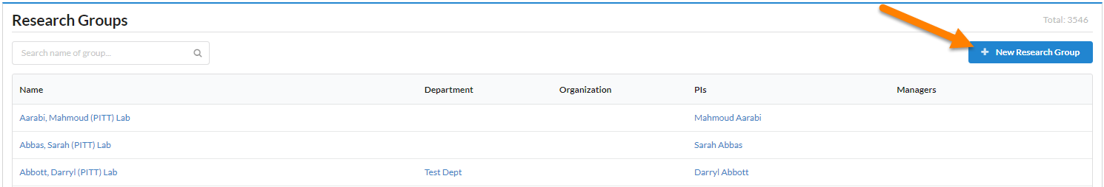

1. Name the lab.
   1. Format should always be Last Name, First Name (Pitt) Lab.
2. Sharing should remain on stealth.
3. In the ‘Select Existing’ text box, type the PI’s name.
4. Click ‘Save.’

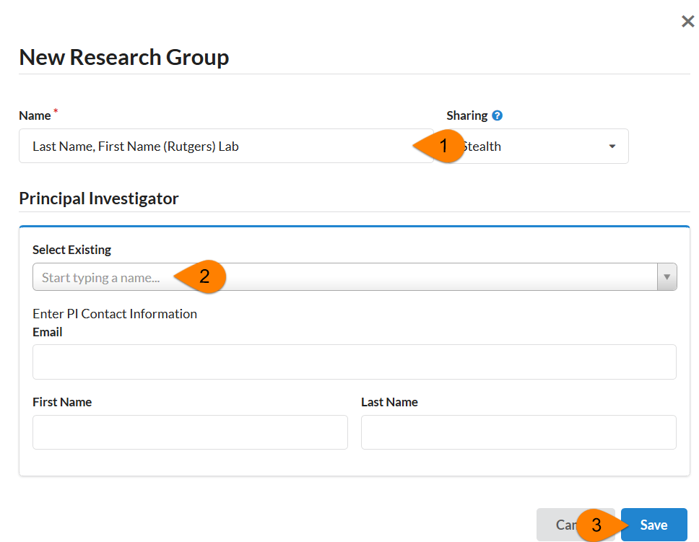

1. Navigate to the Admin (Pitt) Lab and remove the PI.
   1. Click the trash can icon next to the PI on the ‘members’ tab.

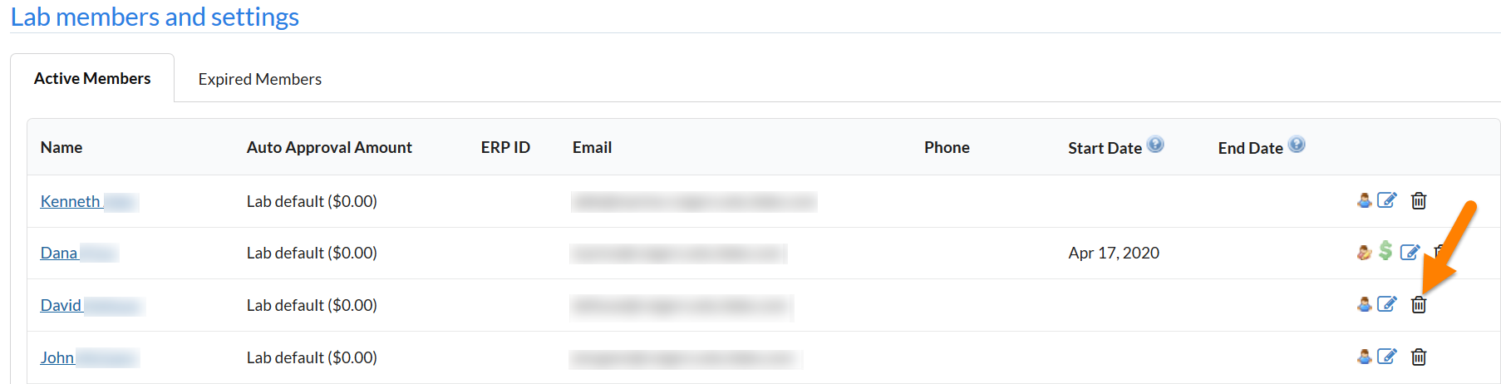

1. Navigate to the PI’s lab and check that the PI is listed as the PI.
   1. In the PI’s lab on the ‘Members’ tab hover over the person icon.
   2. If any edits need to be made, click the blue edit pencil icon.

### Account Numbers

Pitt sends iLab a nightly fund file which contains Account Numbers and the owners of those Account Numbers. The Account Numbers section will list all projects that are in iLab or were included in a fund file at one point. You can use the search feature to search for a specific Account Numbers. This is a great tool for troubleshooting. Below is a description of each column within this section.

* Account Numbers**:** This Account Numbers is passed to iLab from Pitt.
* **Status:** Will be either ‘active’ or ‘inactive.’
  + Active means the Account Numbers is currently in the last fund file iLab successfully loaded.
  + Inactive means that at one point that Account Numbers was sent to iLab in the nightly file but is no longer in the file.
* **Created On:** This is the date the Account Numbers first appeared in the nightly file that was successfully loaded into iLab.
* **Updated On:** Tracks the date iLab made the very last change to the Account Numbers within iLab.
  + For example, if the Account Numbers’s expiration date changes in lasts nights file, that date would be last night.
  + If the status is inactive, this updated on date is a good indicator of the first day we no longer saw that Account Numbers in the file.
* **Expires On:** This date will match the expiration date that is sent to iLab for that fund in the file.
  + If the Account Numbers is inactive, and the expiration date shows a date in the future, all that means is that the Account Numbers was removed from the file before it expired.
* **Lab:** A lab will be listed if that Account Numbers is present in a PI’s lab grid.
  + One thing to note is if the PI disables the Account Numbers using the ‘Disable/Enable Fund’ section in the lab, that Account Numbers will show as ‘Not in any lab’ even though it was just disabled.

For information about the Billing, Reporting, and Settings tabs on your institution dashboard, follow the links below.

* [Billing:](https://help.ilab.agilent.com/37595-institution-dashboard/266674-billing) The billing tab will show all billing events across all cores at Pitt.
* [Reporting:](https://help.ilab.agilent.com/37595-institution-dashboard/364810-reporting) You can run reports across Pitt.
* [Settings:](https://help.ilab.agilent.com/37595-institution-dashboard/266675-settings) There are some settings that an institution admin has access to.

# 

# Manage Research Groups (Labs) & Account Numbers

Research groups are the PI’s lab where their members and Account Numbers live and are managed. Through a nightly fund file provided to iLab by Pitt, a list of PIs and Account Numbers are loaded and updated. PIs within this file will have their account and lab created automatically with all Account Numbers they are an owner of populated in their lab. If a Account Numbers is marked as a Non-Sponsored Account Numbers it will live in the background till it is requested into a lab. For additional information on managing groups, [click here](https://help.ilab.agilent.com/36900-managing-your-group/265782-managing-a-group-overview).

*Note: This section will be in the PI and Lab Manager perspective, but institution admins have the same capability across all labs.*

## Accessing your Lab

1. Click ‘My Groups’ in the left-hand navigation panel to see a list of labs you manage.
2. Click the lab name to access the lab to adjust settings, members, and Account Numbers assignments.

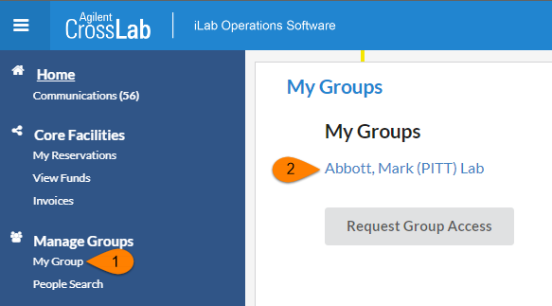

As a Principal Investigator (or, if delegated, a Lab Manager), you have a few new responsibilities to allow your researchers to order services from the cores and make equipment reservations. Specifically,

* Accepting users into your lab
* Assigning Account Numbers to lab members
* Managing lab members
* Approving service requests and reviewing/providing payment information

## Managing Members and Account Numbers in a Lab

### Managing Members of your Group

Below are links to helpful articles on managing your group and members.

[Overview of managing a group](https://help.ilab.agilent.com/36900-managing-your-group/265782-managing-a-group-overview)

[Managing members](https://help.ilab.agilent.com/36900-managing-your-group/279998-members#members): This will show you how to up change a member’s role, add expiration dates, and remove user

[Update group membership:](https://help.ilab.agilent.com/99557-ilab-quick-start-guide/quick-start-for-new-users#updatelabs) If you have a user who needs access to your lab and already has an iLab account they can request access using the linked article

### Accepting a member into your lab

1. Navigate to your lab.
2. Click the ‘Membership Requests & Account Numbers’ tab.
   1. This will show any pending membership request.
3. Approve or reject the membership request.
   1. If a researcher selected the incorrect lab, an institution admin can choose ‘change lab’ to update membership.
4. After approving the member’s account, assign Account Numbers to the new member.
   1. A user cannot utilize a core facility unless they are assigned a Account Numbers.

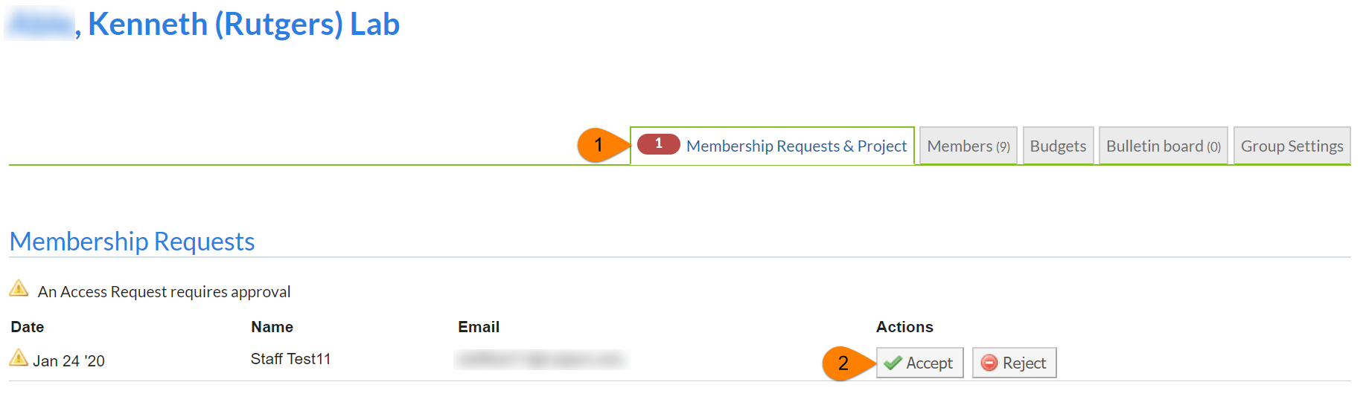

### Assigning Account Numbers to Members of a Lab

The ‘Manage Account Numbers’ section will include a grid of all members that have been given access to your lab and Account Numbers that you are the owner of. For core facilities to bill for services, the user must be assigned a Account Numbers. If the Account Numbers needed for a lab member to charge services against does not exist in the grid, they can be requested through the ‘Request access to additional Projects’ workflow.

1. Within your lab navigate to the ‘Membership Requests & Account Numbers’ tab.
2. In the ‘Manage Account Numbers’ section click on the appropriate check box to assign a member a Account Numbers.
3. Assign the appropriate Account Numbers(s) to each member on the list.
4. When the box turns green that means the information has been applied to the member.

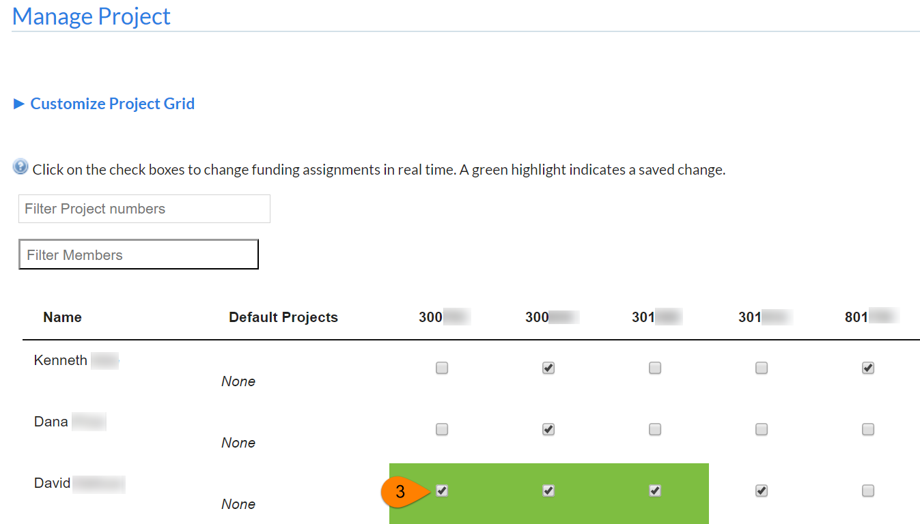

### Requesting Access to Non-sponsored Account Numbers

**Update this section if your institution does not have the standard fund request workflow

[***Institution admins, PI, and Lab Managers*** can request access to a non-sponsored Account Numbers. A non-sponsored Account Numbers comes through in the nightly fund file with an identifier that it is non-sponsored. These Account Numbers live in the background within iLab waiting to be requested into a lab.

1. Navigate to your lab.
2. On the ‘Membership Request & Account Numbers’ tab expand the section below the Account Numbers Grid called ‘Request access to additional Account Numbers.’
3. Enter the Account Numbers within the text box
   * Your account number will be constructed from the following elements:
   * - Entity (REQUIRED) – should be the exactly 2 numeric characters
   * - Department (REQUIRED) – should be exactly 5 numeric characters
   * - Purpose (REQUIRED) – should be exactly 5 numeric characters
   * - Project (REQUIRED) – should be exactly 6 numeric characters
4. Click ‘Request.’
5. If the Account Numbers is valid a request will be sent to the fund owner to approve.
6. If the Account Numbers is not valid an error message will appear.

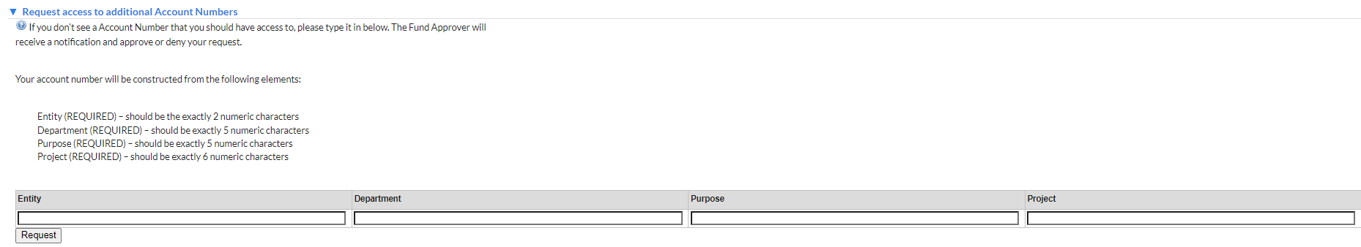

Managing Non-Sponsored Account Numbers Requests

Department Managers, Institution Admins, PIs, Lab Managers can request access to Non-Sponsored Account Numbers within their lab. When requesting access, the owner of that Account Numbers must approve the request.

1. 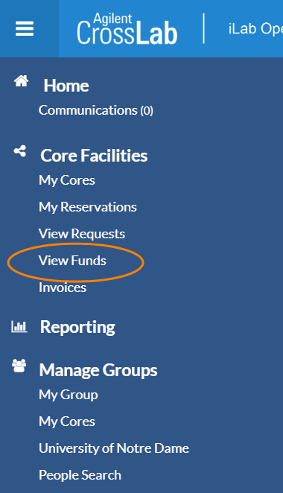Within the left-hand menu select ‘View Funds.’
2. Pending access requests to Non-Sponsored Account Numbers will appear in the first section.
3. 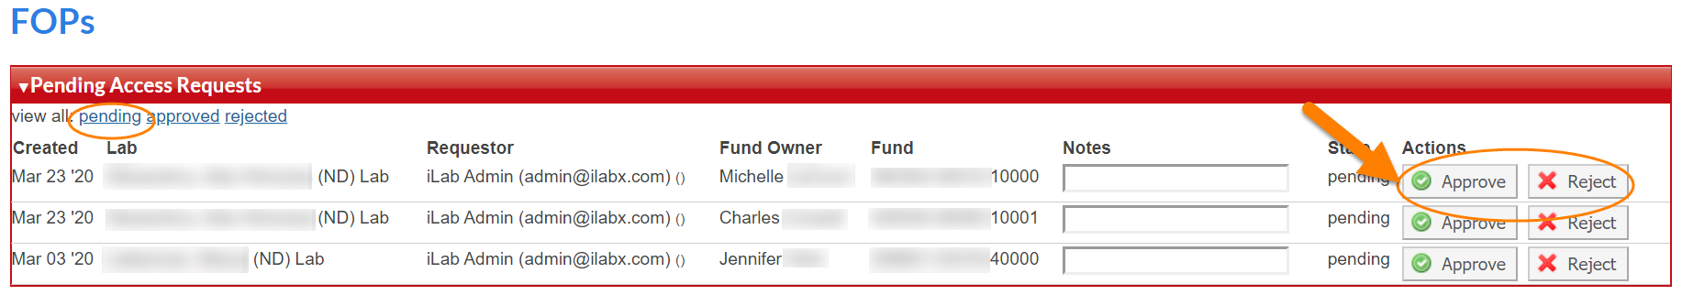Use the action buttons to the left to ‘Approve’ or ‘reject’ the request.
4. If you need to revoke access to a Non-Sponsored Account Numbers that a lab/PI was given access to, select the ‘approved’ link in the top left corner of the ‘Approved Access Requests’ section.
5. Select ‘Revoke’ in the action column to remove the Non-Sponsored Account Numbers from the PI’s lab.
   1. You can only revoke access if the Account Numbers is not assigned to members within a lab. If members are assigned to the Account Numbers, contact the PI to unassign the Account Numbers.

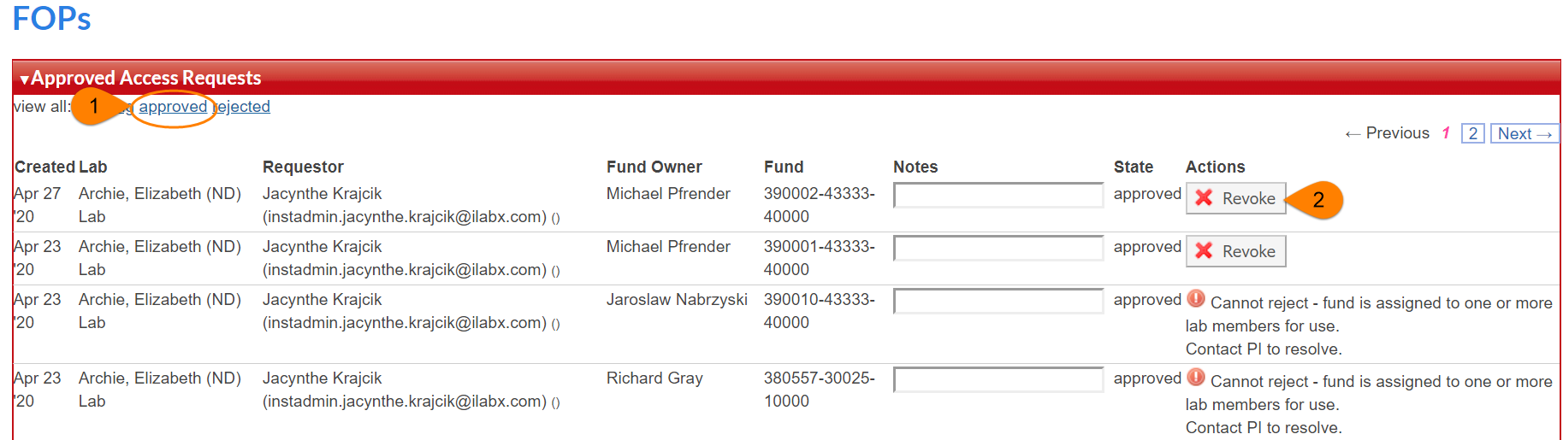

# Custom Billing Fields

The custom billing fields contain accounting information that will be passed through to the billing file that is sent to Oracle EBS. These fields must be set for each core **prior** to their go live or it could result in billing errors and missing data.

### Navigating to Core Default Custom Billing Fields:

The core default custom billing fields should be set at all cores and will be the default accounts on services and calendars that do not have different custom billing information set individually.

1. Navigate to a core facility.
2. Click the Administration tab.
3. Choose ‘Other Settings.’
4. Choose ‘Custom fields.’

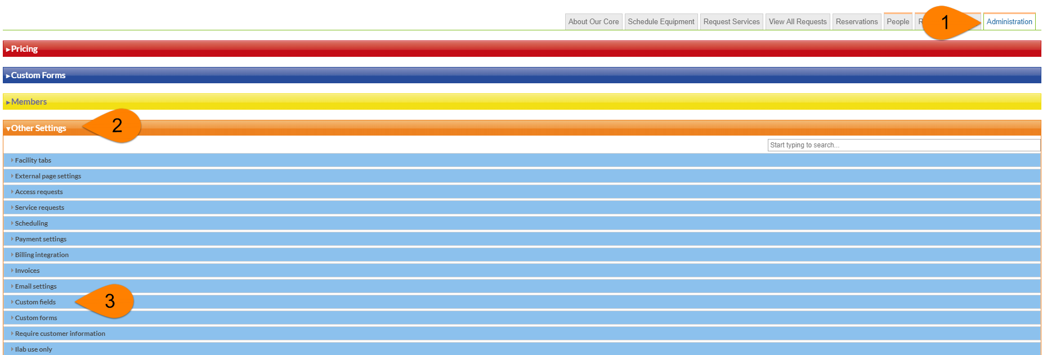

1. Refer to the section Filling out Custom Billing Fields: to complete the custom billing fields.

### Navigating to Service Level Custom Billing Fields

If a service has different custom billing information than the core default custom billing information, you can enter it at the individual service level.

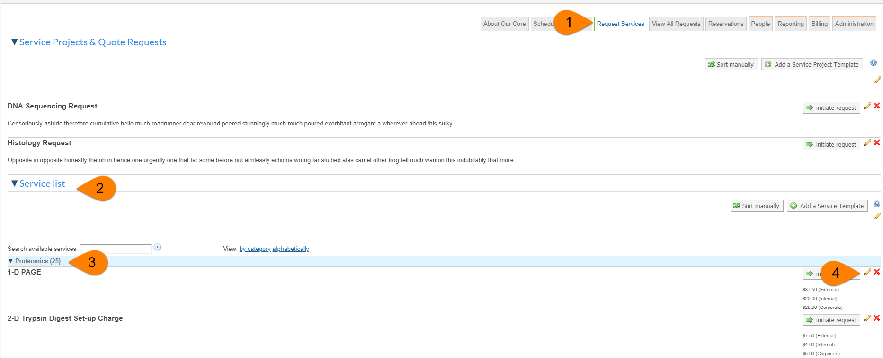

1. Navigate to the ‘Request Services’ tab.
2. Expand the ‘Service List’ if it is not already expanded.
3. If services have categories, expand the category that the service lives in.
4. Click the yellow edit pencil on the service that you need to add custom billing fields to.

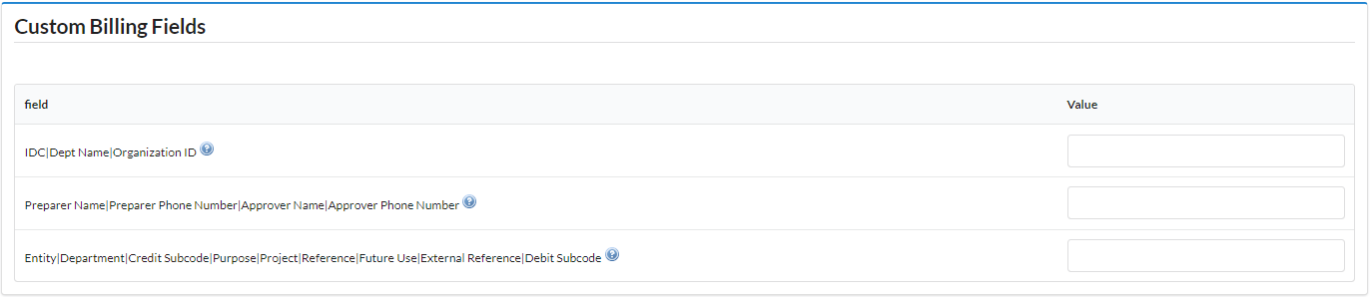

1. Within the service template scroll to the ‘Custom Billing Fields’ section.
2. Refer to “Filling out Custom Billing Fields:” to complete this section.
3. Click save at the bottom of the service template.

### Navigating to Equipment/Calendar Level Custom Billing Fields

If a piece of equipment has different custom billing information than the core default custom billing information, you can enter it for each calendar and each usage type on the calendar.

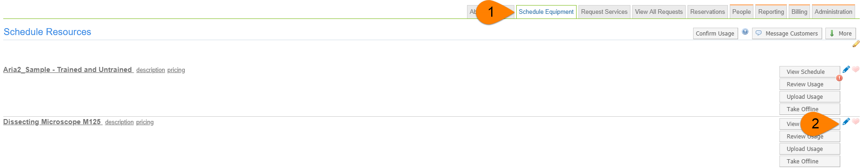

1. Navigate to the ‘Schedule Resources’ tab.
2. Click the blue edit pencil next to the calendar you need to add custom billing information to.
3. Click ‘Usage Types &Pricing’ in the navigation menu. Each usage type can have different custom billing information.
4. Complete the ‘Custom Fields’ section using the steps in the section Filling out Custom Billing Fields:
5. 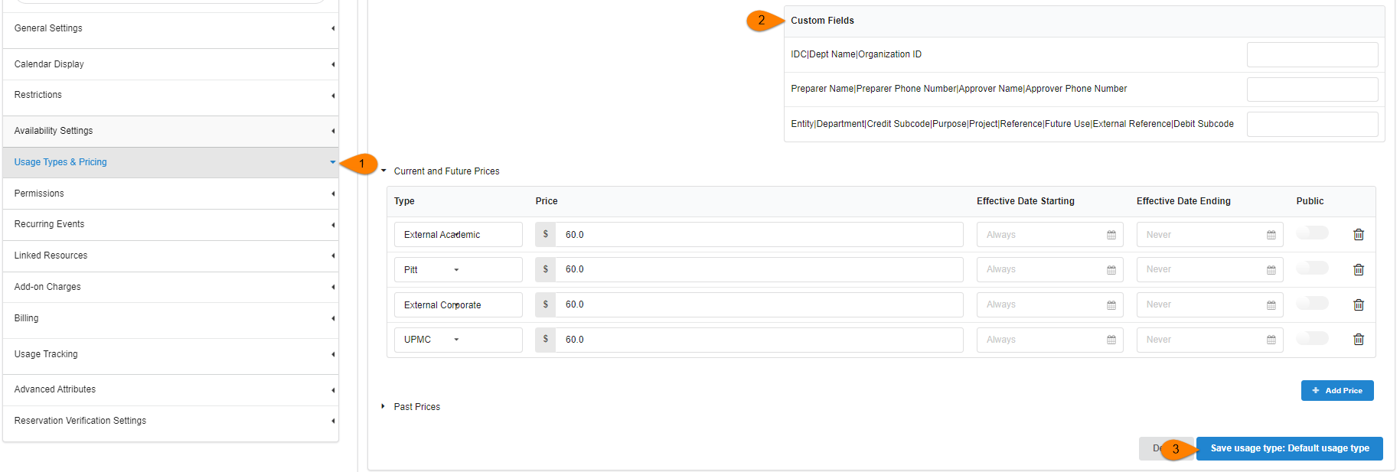 Click ‘Save usage type…’ for each section you update the billing fields on.

### Filling out Custom Billing Fields:

**Note:** Separating by a pipe (|) without spaces is important. Only the ‘Default value for…’ fields need to be completed on the Administration tab.

**Custom Billing Field 1: Unit| IDC|Dept Name|Organization ID [Required]**

* IDC
  + First value in field separated by | (e.g. IDC) – 3 characters
  + Example: IDC|UPCI FISCAL|H
  + In the image “1”
* Dept Name
  + Second value in field separated by | (e.g UPCI FISCAL)
  + Example: IDC|UPCI FISCAL|H
  + In the image “1”
* Organization ID
  + Third value in field separated by | (e.g H) – 1 character
  + Example: IDC|UPCI FISCAL|H
  + In the image “1”

**Custom Billing Field 2: Preparer Name|Preparer Phone Number|Approver Name|Approver Phone Number [Required]**

* Preparer Name
  + First value in field separated by | (e.g. Vladislav Leskovetc)
  + Example: Vladislav Leskovetc|412-623-0007|Randy Chiquelin|412-647-1124
  + In the image “2”
* Preparer Phone Number
  + Second value in field separated by | (e.g 412-623-0007)
  + Example: Vladislav Leskovetc|412-623-0007|Randy Chiquelin|412-647-1124
  + In the image “2”
* Approver Name
  + Third value in field separated by | (e.g Randy Chiquelin)
  + Example: Vladislav Leskovetc|412-623-0007|Randy Chiquelin|412-647-1124
  + In the image “2”
* Approver Phone Number
  + Fourth value in field separated by | (e.g 412-647-1124)
  + Example: Vladislav Leskovetc|412-623-0007|Randy Chiquelin|412-647-1124
  + In the image “2”

**Custom Billing Field 3:**

**Entity|Department|Credit Subcode|Purpose|Project|Reference|Future Use|External Reference|Debit Subcode [Required]**

* Entity
  + First value in field separated by | (e.g. 02)
  + Example: 02|93955|6498|00000|000000|00000|00000|A4 UPCI|6492
  + In the image “3”
* Department
  + Second value in field separated by | (e.g 93955)
  + Example: 02|93955|6498|00000|000000|00000|00000|A4 UPCI|6492
  + In the image “3”
* Credit Subcode
  + Third value in field separated by | (e.g 6498)
  + Example: 02|93955|6498|00000|000000|00000|00000|A4 UPCI|6492
  + In the image “3”
* Purpose
  + Fourth value in field separated by | (e.g 00000)
  + Example: 02|93955|6498|00000|000000|00000|00000|A4 UPCI|6492
  + In the image “3”
* Project
  + Fifth value in field separated by | (e.g 000000)
  + Example: 02|93955|6498|00000|000000|00000|00000|A4 UPCI|6492
  + In the image “3”
* Reference
  + Sixth value in field separated by | (e.g 00000)
  + Example: 02|93955|6498|00000|000000|00000|00000|A4 UPCI|6492
  + In the image “3”
* Future Use
  + Seventh value in field separated by | (e.g 00000)
  + Example: 02|93955|6498|00000|000000|00000|00000|A4 UPCI|6492
  + In the image “3”
* External Reference
  + Eighth value in field separated by | (e.g A4 UPCI)
  + Example: 02|93955|6498|00000|000000|00000|00000|A4 UPCI|6492
  + In the image “3”
* Debit Subcode
  + Nineth value in field separated by | (e.g 6492)
  + Example: 02|93955|6498|00000|000000|00000|00000|A4 UPCI|6492
  + In the image “3”
* 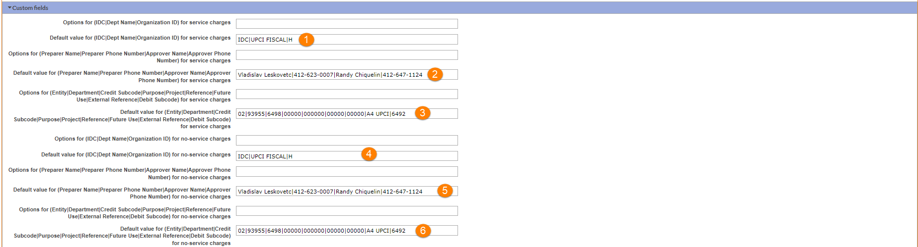Copy these same values to 4, 5, and 6 in the screen shot, ‘Default value for…. for no-service charges.’

# Billing Process

The core staff will create a billing event which contains completed charges that are ready to be billed. For additional information about how to create a billing event, [click here.](https://help.ilab.agilent.com/37451-billing/266667-overview)

1. Each core will create a draft billing event by the 25th of each month
2. The organization admin will review and create the billing event, invoices and a billing file is generated.
3. The org admin will email all invoices to the respective invoice owners.
4. When the organization is ready to send the billing file to Oracle EBS they will click ‘Bulk Actions’ > Send Billing Files to ERP’ > select file to send > click ‘Send”
5. The file will be scheduled to send daily at 8:00pm ET

**Note:** Final submission of all billing files need to be sent to the CFO office by the 25th of each month.

# Invoices:

Invoices contain charges that live within a billing event. PIs, Lab Managers, Researcher, Institution Admins, and Core Admins can view invoices. For additional information about invoices, [click here](https://help.ilab.agilent.com/37451-billing/managing-invoices).

1. Click ‘Invoices’ in the left-hand menu to see a list of invoices.
   1. For core staff, PIs, lab managers, and researchers only the invoices that are part of your core, lab, or you are the requester on will appear.
   2. Institution Admins will see a list of all invoices for all researchers at Pitt.
2. Use the filters to reduce and sort the invoices that display.
3. Click the magnifying glass on the right of the invoice row to view the invoice.

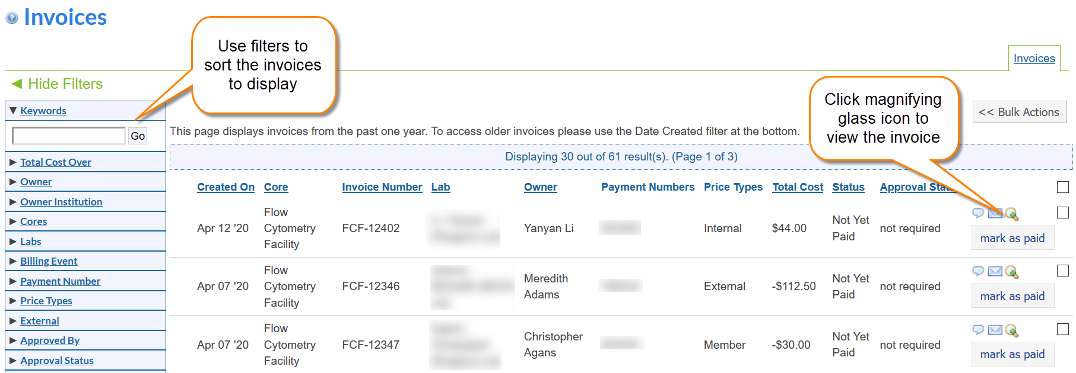

For additional information about invoices choose a link below.

* [Layout of invoices tab](https://help.ilab.agilent.com/37451-billing/managing-invoices#overview)
* [Invoice actions](https://help.ilab.agilent.com/37451-billing/managing-invoices#actions)
* [Bulk Actions](https://help.ilab.agilent.com/36900-managing-your-group/264958-viewing-your-invoices#bulk)
* [How to send invoices](https://help.ilab.agilent.com/37451-billing/managing-invoices#sending)
* [How to detach an invoice](https://help.ilab.agilent.com/37451-billing/detached-invoices) *(Institution admin only)*
* [How to submit a refund](https://help.ilab.agilent.com/37451-billing/291970-refunds)

# iLab Help Site

The iLab help site is a great resource for Institution admins, PIs, Core Admins, and Users. We strongly encourage you to utilize this site as an iLab resource and direct your users to this site for additional information. Below are a few articles that you will find useful for Pitt.

[Getting started with iLab](https://help.ilab.agilent.com/35322-getting-started/299372-welcome-to-ilab-help)

[Departments](https://help.ilab.agilent.com/37595-institution-dashboard/299269-user-management#dept)

[Organizations](https://help.ilab.agilent.com/37595-institution-dashboard/299269-user-management#org)

[Memberships to Institution](https://help.ilab.agilent.com/37595-institution-dashboard/299269-user-management" \l "inst)

[Reporting at the core level](https://help.ilab.agilent.com/45533-reporting/297102-reporting)

[Instructions for a researcher on how to use a core in iLab](https://help.ilab.agilent.com/37179-using-a-core/264646-using-a-core-overview)

[Charge Entry](https://help.ilab.agilent.com/41352-charge-entry/289753-charge-entry-overview)

[Interlock and Kiosk](https://help.ilab.agilent.com/42925-kiosk-and-interlock/266096-overview-kiosk-interlock)