University of Pittsburgh

Organization Centralized Billing Manual

Table of Contents

Overview 1

Generating and Sending Billing Files at the Institution Level 1

Billing Errors 3

Billing errors when creating billing event 3

Billing errors after billing event has been created 4

Invoices: 5

Advanced Invoice Features 5

# Overview

The iLab/Pitt Financial Integration allows PIs, Financial Managers, Researchers and Core Managers to use valid Account Numbers when making a reservation or submitting a request. This document outlines the billing process that Pitt has put into place.

Pitt follows a centralized billing workflow which means there is a central point of contact who will generate billing files and invoices then send the final billing file to Oracle EBS.

The first step in the billing process is for the cores to create a billing event for review. Core administration must submit all billing events for review monthly by the 25th. See ‘Pitt: Core Billing Manual’ for core responsibility during the billing process.

# Generating and Sending Billing Files at the Organization Level

Weekly, bi-weekly, or monthly, the designated central biller(s) will generate all billing events that are in a *Pending Review* status. When generating the billing events the invoices and custom billing file will be generated, and invoices can be sent to the PIs or lab mangers. Once billing events have been created, the central biller will send the billing file to Oracle EBS.

1. Navigate to your Organization by clicking on the three vertical lines.

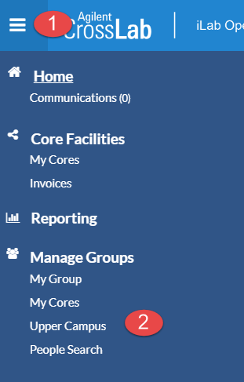

1. Click the name of your Organization (Hillman, Lower Campus, or Upper Campus). Then click on the ‘Billing’ tab.
2. To view charges in each billing event, click on ‘Edit’. If no edits or review is needed, you can click on ‘Summary’ and ‘Send File to Pitt GA’.

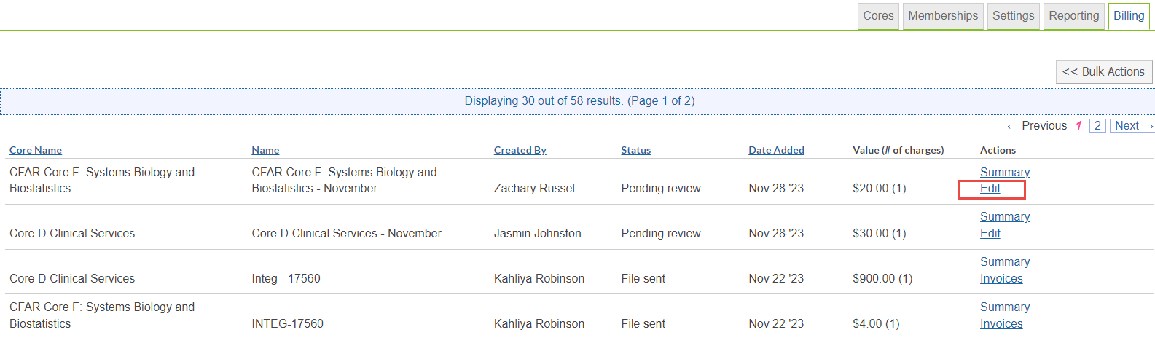

1. If you wish, you can make an edits to this billing event, by updating:
   1. End Date
   2. Event Name
   3. Included charges
   4. Loading additional charges
   5. Updating the account number
   6. Including or excluding charges
2. After you have made your edits (or if no edits were made) you can click on ‘Create Billing File and Invoices’.
   1. The billing file is now in ‘Billing Initiated’ status. Click on ‘Summary’ and ‘Send File to Pitt GA’ when you are ready to send the billing files to Oracle EBS.
3. The billing events will move to a ‘Ready to Send’ status.
4. Daily at 8pm ET iLab will generate one large billing file using all billing events that are in a ‘Ready to send’ status then drop the file on the server for Oracle EBS to process.
5. Once iLab drops the file on the server the status of the billing events will change to ‘File Sent’
   1. *Important Note:* Internal invoices are automatically marked as ‘Paid’ when the billing event changes to a file sent status. External invoices will manually be marked as ‘Paid.’

# Billing Errors

Billing errors would appear on a billing event if an Account Number were missing from a charge or if core custom billing fields are missing.

## Billing errors when creating billing event

When the core admins are creating their billing event for the Organization Financial Admin to review, they may see red flags on charges indicating there is a billing error. These errors are due to missing Account Numbers. The cores should correct these errors before submitting the billing event to the Organization Admin to review.

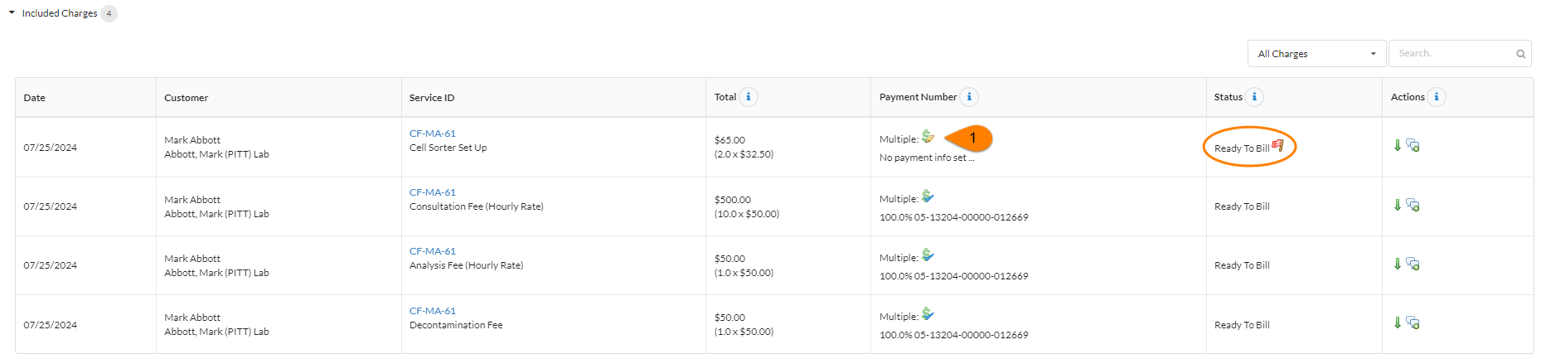

## Billing errors after billing event has been created

When the core sends a billing event to the Organization Financial Admin for review, if there are errors on a billing event the status change to ‘Billing Errors’ after the Organization Admin creates the billing event. If a billing event has billing errors all charges on the billing event cannot be sent to Oracle EBS to be processed. These billing errors must be fixed by an Organization Admin.

1. On the institution billing tab click the ‘Summary’ link next to the billing event with errors
2. Within the billing event click the ‘Billing Errors’ tab
3. The invoices that contain a billing error will be listed with the error
4. The possible errors are: Missing PI, Internal: HasNegativeQuantity, Missing Custom Billing Fields
   1. **Charges Missing PI:** This means that a charge was made by a user that is not associated with a research group. To correct this a Institution Admin will need to add the user to the proper PI’s lab.
   2. **Internal Charges Has Negaive Quantity:** This means that a charge has a negative quanity and the core did not follow the workflow to initiate the refund.
   3. **Charges Missing Custom Billing Information:** This means that the Core’s custom billing fields are missing or formatted incorrectly on the administration tab or service. This error is more likely to occur at time of first iLab billing cycle. To avoid this enter the core’s custom billing information prior to the core going live.
      1. Refer to the institution manual for instructions on adding custom billing information.
5. To update the payment information on the charge with the error follow the steps below.
   1. Click view invoice on the ‘Billing errors’ tab
   2. There will be a red arrow pointing to the charge with the error
   3. Click the dollar icon to add/update the Account Number
   4. Navigate to your previous tab in your browser which shows the billing errors tab
   5. Click ‘Revalidate’
   6. If the Account Number provided is valid and the error is fixed, the billing errors tab will dessapear

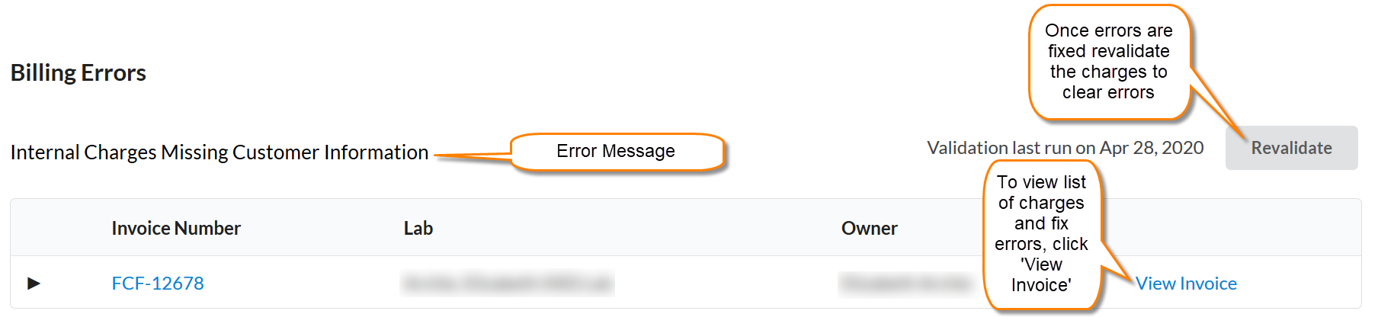

# Invoices:

Within the invoice list you can mark an invoice as ‘paid’ and manually send invoices. Invoices also have other advanced functions/features such as detaching an invoice from a billing event and initiating a refund.

1. Click ‘**Invoices’** in the left-hand menu to see a list of all invoices.
2. Use the filters to reduce and sort the invoices that display.
3. 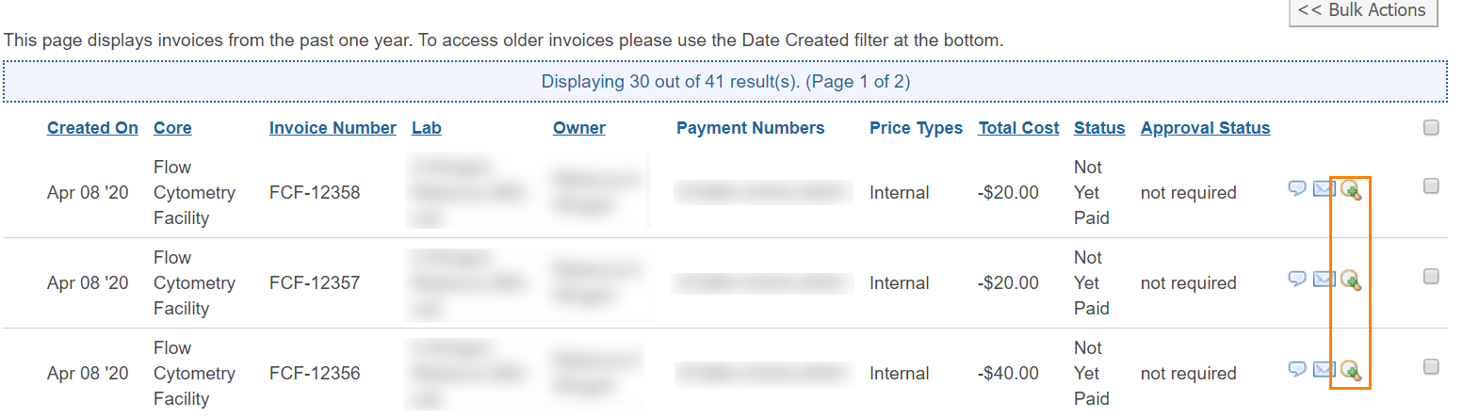To view the invoice, click the magnifying glass on the right of the invoice row.

## Advanced Invoice Features

Below are links to our helpsite which outlines the process for advanced features.

* [Layout of invoices tab](https://help.ilab.agilent.com/37451-billing/managing-invoices#overview)
* [Invoice actions](https://help.ilab.agilent.com/37451-billing/managing-invoices#actions)
* [Bulk Actions](https://help.ilab.agilent.com/36900-managing-your-group/264958-viewing-your-invoices#bulk)
* [How to send invoices](https://help.ilab.agilent.com/37451-billing/managing-invoices#sending)
* [How to dispute a charge on an invoice](https://help.ilab.agilent.com/37451-billing/291725-invoice-disputes?from_search=46584077)
* [How to detach an invoice](https://help.ilab.agilent.com/37451-billing/detached-invoices)
* [How to initiate and process a refund](https://help.ilab.agilent.com/37451-billing/291970-refunds)